Adult Income Analysis and Model
Group
Course Number- Name of Course
Instructor’s Name
Date

Introduction
The US census bureau collects useful demographic data every ten years. This data is deemed useful for social, economic, political, and research purposes. The dataset used in this case study was obtained from the US census bureau database and prepared by Ronny and Barrack to study patterns and classify people into earning less than USD 50000 or greater.
Previous case studies on this dataset adopt traditional statistical models in predicting outcome (income), however, they never analyze how various variables affect income. Most of the studies based on this dataset rarely focus on deriving patterns and understanding relationships among predictors and the target variable.

Objectives
This case study seeks to identify what and how various factors affect an individual’s income and build a machine learning model to predict whether a person earns <=USD 50000 or >USD 50000, given a set of independent variables. The case study adopts analysis by graphs, tables, and K-nearest neighbor to understand patterns and predict the binary target variable. The trained model performs better in training and generalizes well on unseen data. Therefore, this case study complimented with other datasets, depending on the business case, would be helpful in the decision-making process for entities that leverage data-driven decisions.

- Study how various factors affect an individual’s income.
- Conduct feature engineering to improve model performance.
- Predict whether a person earns <=50k or >50k.

Data
Dataset was extracted from the 1994 census database and prepared by Ronny Kohavi and Barry Becker and published on www.kaggle.com. The data has 32561 records and 15 variables that capture the socio-economic details of individuals.

Feature Engineering and Preprocessing
The dataset contains 6 continuous variables and 9 categorical features. Some variables like country of origin and fnlwgt were dropped. Creating new categorical variables from continuous variables, through binning, made it easier to visualize them versus the target variable and compute correlations. Besides, categories with few samples were renamed to one category reducing the number of levels in categorical variables. This technique guaranteed fewer levels in variables.
New features were derived from observing patterns between two variables or performing math operations on two variables. For instance, edu_grps derived from years spent in school and education level. Consequently, the two original variables were dropped and replaced by the new variable. Net_capital was calculated by subtracting capital loss from capital gain. This acts as a dimensionality reduction technique, high dimensionality reduces performance in distance-based algorithms (Sebastian, 2015).

There was a challenge identifying missing values, however, after conducting more exploration ‘?’ was spotted in 3 columns (occupation, work-class, native country), this value was replaced with Na to denote missing value. Plotting histograms was important in visualizing how continuous variables are distributed.

The missing values in 3 categorical variables were replaced by mode. Ordinal categories were mapped to integer values in ascending order starting from 0, applied for age_grp, edu_grp, work_hours. Nominal variables were transformed to numeric by one-hot-encoding. This method creates a new column for each category and assigns 1 where the category is present and 0 otherwise (Sebastian, 2015). This method introduces a high dimensionality problem in case of too many categories. However, it does not cause bias in data.

Distance-based algorithms like k-nearest neighbors perform poorly with unscaled data (Sebastian, 2015). Therefore, feature scaling was necessary to bring down these values to a common scale. StandardScaler in sklearn was used to transform features to values between -1 to 1.

Model
The dataset was split into train and test sets in a 70:30 ratio. The train set trained the model using a cross-validation technique with 10 folds. Cross-validation negates the need to hold out a validation set since the available data was small. Besides, cross-validation helped choose the optimum value for k-neighbors. Hence the resulting model does not over-fit or under-fit the data.
The optimum value of k was computed by training a model for k-values ranging from 1 to 30 and cross-validation accuracy was recorded for each value of k. The average accuracy at k-neighbor is the mean accuracy for the 10 folds, while the standard deviation accounts for variance in the accuracy scores. Consequently, the optimal value of k-neighbor is the value at which the standard deviation is minimal and average accuracy is maximum.

The cross-validation average score shows an upward trend and reaches its maximum at k=23, average accuracy at this point is 83.3. However, variance in accuracy score is not minimal at this point. A model that shows consistency (low variance in validation accuracy) is better than an inconsistent model with high accuracy. Therefore, variance in accuracy score was considered when selecting an optimal value for k. From the second graph, variance was low when k=3. Thus, the best fit model was trained with k=3 as a parameter for nearest neighbors.

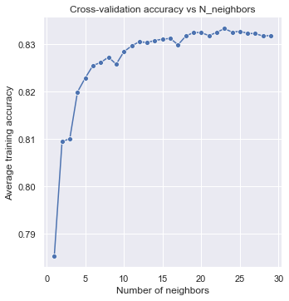
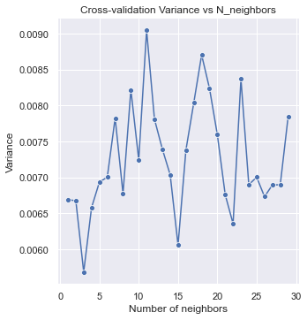
The best fit model predicted unseen data with an accuracy score of 81.4%. This was close to the training accuracy of 81%. The accuracy of predicting unseen data is slightly higher. The accuracy score is not the best metric for our classification problem. Therefore AUC-ROC metric was used to check model performance.
This metric measures model specificity and sensitivity. Sensitivity is when a model predicts a negative outcome when the actual value is negative while specificity is when a model predicts a positive outcome when the actual value is positive. The value of AUC ranges from 0-1, as the value tends to 1 the better the model. Our model was able to predict classes well with AUC =0.81.
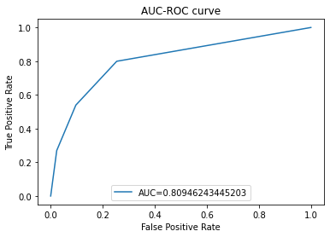

Conclusion

This approach to machine learning based on feature engineering to improve data quality and cross-validation for tuning parameter k improved our model performance compared to previous models that were trained on this data which achieved AUC 73. Visualizing new categorical features versus income gave a clearer picture than visualizing continuous variables versus income. Besides, computing correlation between continuous predictor variables and categorical target variable was possible after binning continuous variables.

References
Sebastian (2015). Python Machine Learning

